VISHWAKARMA UNIVERSITY
Academic Year: 2025-26 | Semester II
ADVANCED WEB TECHNOLOGY
NAME OF THE STUDENT : | Aaditya Dhanwate
DEPARTMENT : | ARTIFICIAL INTELLIGENCE & DATA SCIENCE
CLASS / DIV. : | TY / A
SRN : | 31230319
ROLL NO. : | 8

ASSIGNMENT NO.: 05
Create a Custom Server using the HTTP Module and Explore Other Core Node.js Modules
OBJECTIVE:
• Build a custom HTTP server using Node.js http module (without Express.js)
• Use the os module to retrieve real-time system information (platform, memory)
• Use the path module to display file path details in the browser
• Use the events module to emit a custom event when the server starts

Problem Statement: Create a custom server using Node.js's built-in http module with routes for Home, About, System Info, and Path Info pages. Integrate the os module for hardware details, the path module for file path information, and the events module to emit a custom event on server startup.
Code (server.js):
const http = require('http');
const os = require('os');
const path = require('path');
const EventEmitter = require('events');

// --- Part 4: Events Module ---
class ServerEmitter extends EventEmitter {}
const serverEvents = new ServerEmitter();

serverEvents.on('serverStarted', (port) => {
console.log(`[Event Triggered]: Server started!`);
console.log(`Running at http://localhost:${port}`);
// --- Part 3: Path Module (Console) ---
console.log('__dirname:', __dirname);
console.log('path.basename():', path.basename(__filename));
console.log('path.extname():', path.extname(__filename));
});

// Helper: Generate HTML responses
const generateHTML = (title, content) => `
<!DOCTYPE html><html><head><title>${title}</title></head>
<body><div class='container'>
<nav>Home | About | System Info | Path Info</nav>
<h1>${title}</h1>${content}
</div></body></html>`;

// --- Part 1: Custom HTTP Server ---
const server = http.createServer((req, res) => {
res.setHeader('Content-Type', 'text/html');
if (req.url === '/') {
res.statusCode = 200;
res.end(generateHTML('Welcome to Core Node JS!', '...'));
} else if (req.url === '/about') {
res.statusCode = 200;
res.end(generateHTML('About This App', '...'));
} else if (req.url === '/system') {
// --- Part 2: OS Module ---
const platform = os.platform();
const arch = os.arch();
const totalMem = (os.totalmem() / 1e9).toFixed(2);
const freeMem = (os.freemem() / 1e9).toFixed(2);
res.end(generateHTML('System Information', `
OS: ${platform} | Arch: ${arch}
Total: ${totalMem} GB | Free: ${freeMem} GB`));
} else if (req.url === '/path') {
// --- Part 3: Path Module (Browser) ---
res.end(generateHTML('Path Module Info', `
__dirname: ${__dirname}
__filename: ${__filename}
basename(): ${path.basename(__filename)}
extname(): ${path.extname(__filename)}`));
} else {
res.statusCode = 404;
res.end(generateHTML('404 Not Found', 'Route not found.'));
}
});

const PORT = 3000;
server.listen(PORT, () => {
serverEvents.emit('serverStarted', PORT);
});

Output:
1. Home Page – Welcome to Core Node JS!
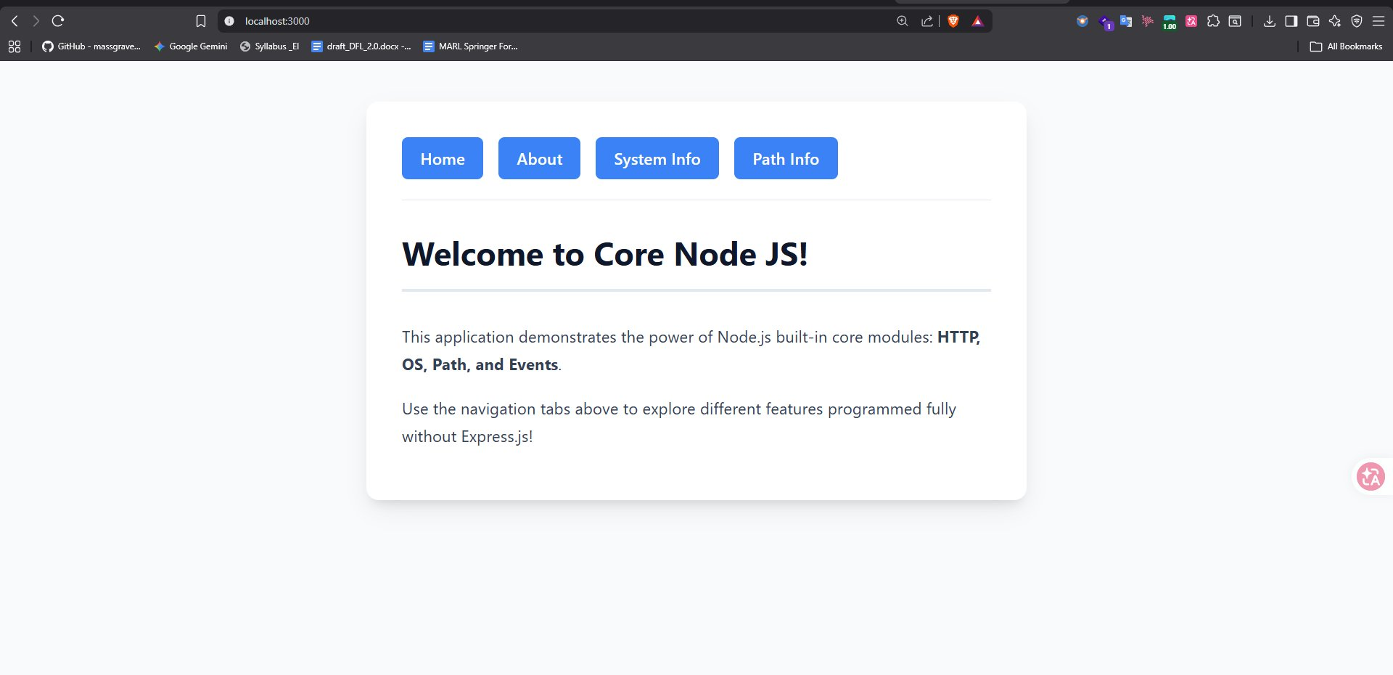
2. About Page – Project Info
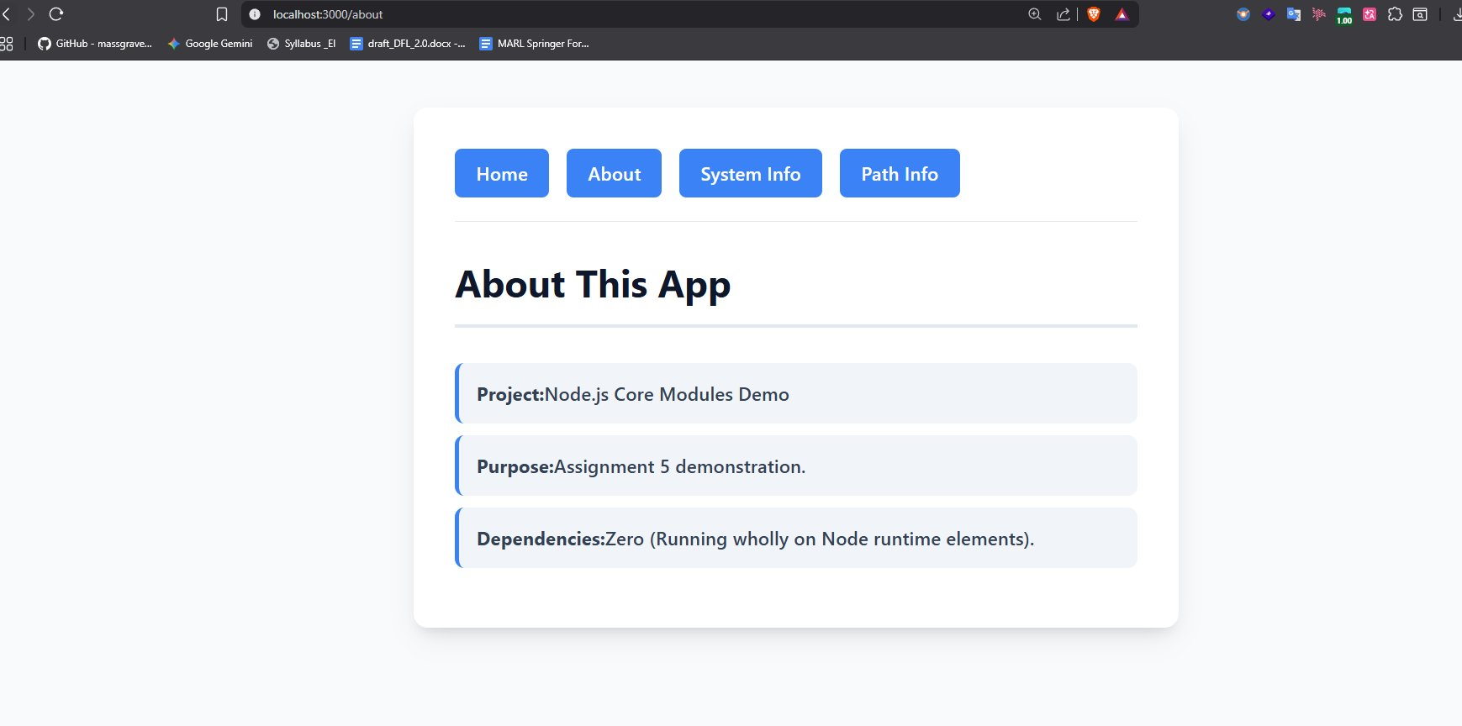
3. System Information Viewer – OS Module
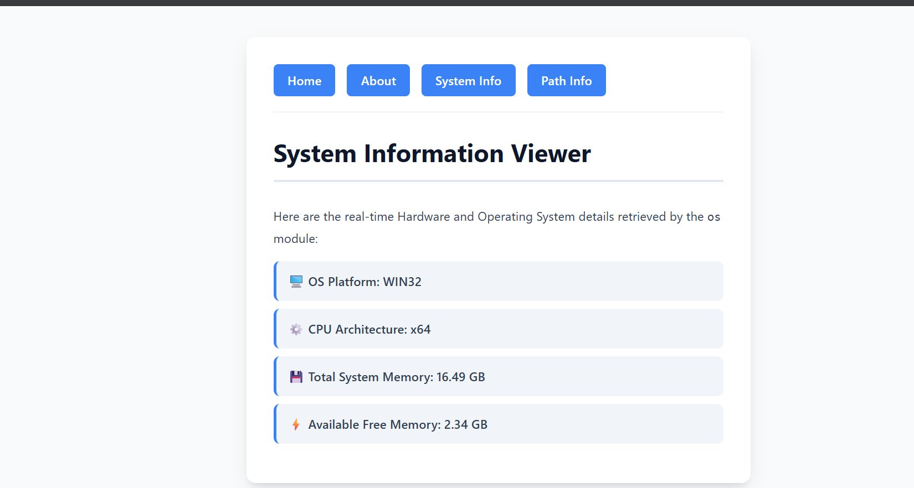
4. Path Module Information Page
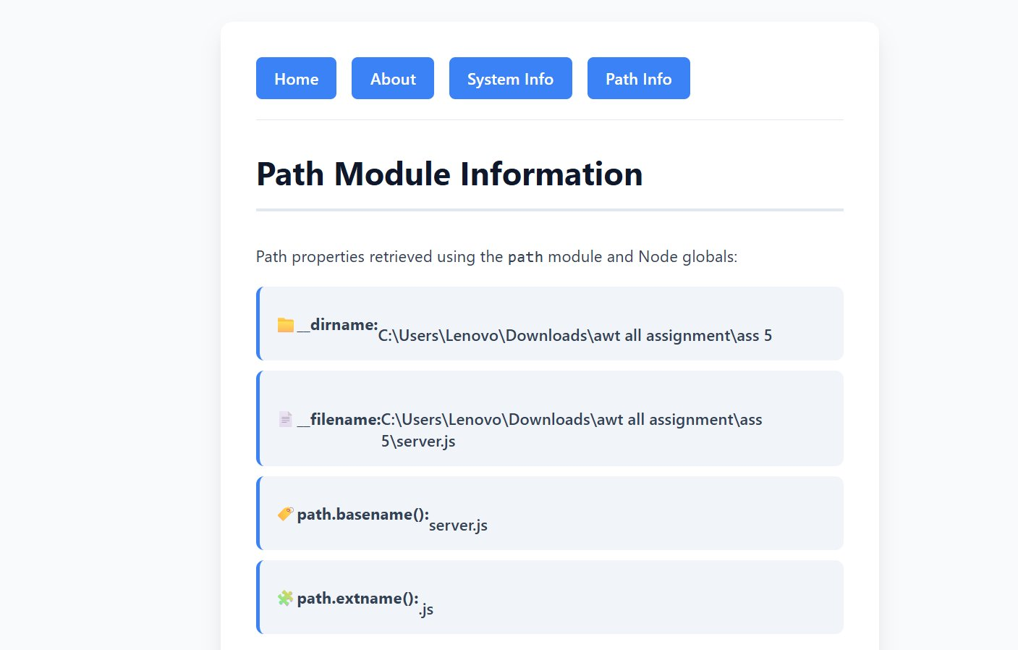

Conclusion:
In this assignment, a custom HTTP web server was built using only Node.js core modules — http, os, path, and events — without any third-party frameworks like Express.js. The server handles multiple routes (/, /about, /system, /path) and returns formatted HTML responses. The os module provides live system hardware data, the path module displays file path details, and a custom EventEmitter class triggers a console event upon server startup.

